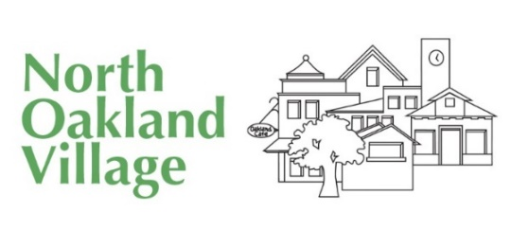
On-Going Groups

North Oakland Village hosts many on-going groups for our Members. Many of these groups are also open to our volunteers. Some groups and activities are open to the public as indicated below.
Monthly On-going groups for Members (Volunteers can join if indicated):
Bridge Group – meets monthly at members home to play bridge. Members and volunteers
Handability Group – Knitting and Crocheting in Good Company & for a Good Cause – Once a month the group meets in the NOV Office to knit items to donate to hospitals. Members and volunteers
Member Salon – a group of people who get together at a member’s home to discuss interesting topics and enjoy one another’s company. Members only
Monday Menders – Every Monday at 12:30 a drop in session for sewing, quilting, crocheting and other stitchery projects. Bring mending with which you need help. No instruction provided but we do offer support, advice and company. Members and volunteers
Lunch Bunch – The lunch bunch group is a group that has become extremely popular. Every month people get together at a different restaurant for lunch. Usually has about 6-8 people, and restaurants are chosen to keep the price modest. Members and volunteers

Non-Fiction Book Group – each month the group selects a non-fiction book of interest to read and discuss. Held at the NOV office – Members only
Movie Group – each month, any interested movie buffs can join the movie group to see a film at a local cinema. Movie decision are made by group consensus. Sometimes this will include a meal before or after. Members and volunteers
Play Reading Group – roughly each month a group meets to read from a play. Members and volunteers
Memoir Group – With an instructor, people learn how to put together their memoirs and tell their story. Members and volunteers
Current on-going groups open to the public:
Monthly Potluck – On the last Sunday of each month from 5:00-7:00 pm we meet at the Village to share food in good company. Members, Volunteers and the Public are encouraged to attend. There is no charge. Just bring a dish to share.
For more information please contact North Oakland Village at: Phone: (510) 547-8500 or e-mail: info@northoaklandvillage.org website: www.northoaklandvillage.org

